Discovery 6: Troubleshoot EtherChannel
Introduction

In this lab, you have two switches, SW1 and SW2 connected via four GigabitEthernet links. The GigabitEthernet interfaces have been bundled to form two EtherChannels as shown in Topology. The interfaces E0/0 and E0/1 have been grouped to form Port-channel 1 while interfaces, E0/2 and E0/3 have been grouped to for PortChannel 2 on the two switches. PC1 and PC2 are in VLAN 11. Dot1q trunking has been enabled on the interfaces. The switches are intended to operate with devices of other vendors, therefore, only standardized protocols should be used. Switch SW1 needs to initiate the EtherChannel while switch SW2 should only respond to it.
Following are some of the issues seen after configuration. You need to troubleshoot and resolve these issues.
- Port-channel 2 on SW2 is in down state.
- On SW1, the interface E0/0 is not part of the Port channel group 1.
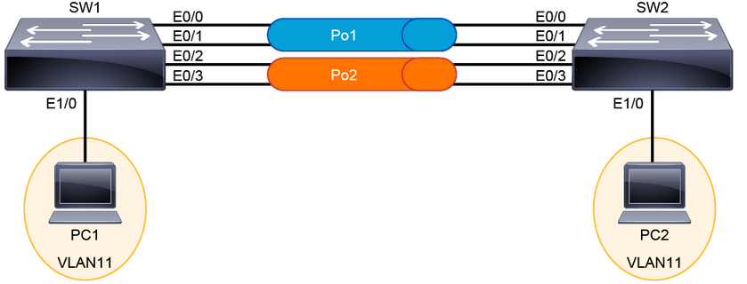

Task 1: Troubleshooting EtherChannel Issues

Activity

Step 1: Verify that PortChannel 2 is in down state.
Use show etherchannel summary command on SW2.
SW2# show etherchannel summary
From the output, you can see that Po2 shows as SD, where S stands for Layer 2 and D denotes the down state. You can also see that interfaces E0/2 and E0/3 are part of this EtherChannel. The PortChannel mode used is LACP.

Step 2: Verify the PortChannel 2 state on SW1
Use show etherchannel summary command on SW1.
SW1# show etherchannel summary
You will notice that the PortChannel mode is set to default. The PortChannel establishment protocol should match on both switches. The interfaces grouped are correct. You need to configure SW1 to use LACP as the protocol for the EtherChannel to come up.

Step 3: On SW1, configure the interface E0/2 and E0/3 to use LACP as the channel establishment protocol. SW1 should be initiating the etherchannel.
First, verify the configuration on interfaces GigabitEthernet0/2 and GigabitEthernet 0/3 on SW1

SW1#show run interface GigabitEthernet 0/2

SW1#show run interface GigabitEthernet 0/3

Next, configure the ports to use LACP as the etherchannel establishment protocol

SW1(config)#interface range g0/2-3
SW1(config-if-range)#no channel-group 2 mode on

SW1(config-if-range)#channel-group 2 mode active
You will still see that PortChannel 2 has not been enabled.

SW1# show etherchannel summary
Next step would be to check the EtherChannel configuration on both switches.

Step 4: On SW2 and SW1, use the show run interface port-channel 2 command.
You will notice that SW1 has all VLANs allowed while SW2 is not allowing VLAN 11.
SW2# show run interface port-channel 2
For the etherchannel to be enabled, the following must match: mode (access or trunk), VLAN number (for access interfaces), native VLAN, and the VLANs allowed and encapsulation (for trunk interfaces). Therefore, the allowed VLAN range should match on the trunk interface.

Step 5: Resolve the issue on Port channel 2 by allowing all VLANs.
Enter the following commands on SW2.
enter configuration commands, one per line. End with CNTL/Z.

SW2(config)# interface port-channel 2
SW2(config-if)# no switchport trunk allowed vlan 1-10,12-4094

Verify that Port-channel is now enabled. It may take a couple of minutes.
SW2# show etherchannel summary

SW1# show etherchannel summary
Step 6: On SW1, the interface E0/0 is not part Port Channel group 1. Use show etherchannel summary command to verify the issue.
Enter the following command on SW1.
SW1# show etherchannel summary

SW1# show run interface GigabitEthernet 0/0
You will notice that interface has been changed to Layer 3 using no switchport command. Also, the interface has not been added to channel group.

Step 7: Resolve the issue on SW1 by configuring the interface GigabitEthernet 0/0 correctly.
First, enable the port for trunking and it should use dot1q.
Enter configuration commands, one per line. End with CNTL/Z.
SW1(config)# interface GigabitEthernet 0/0
SW1(config-if)#switchport
SW1(config-if)# switchport trunk encapsulation dot1q
SW1(config-if)# switchport mode trunk

Now, add the interface to Port channel 1.
SW1(config)# interface GigabitEthernet 0/0
SW1(config-if)#channel-group 1 mode active

Now, verify that the PortChannel 1 has both interfaces added and enabled.
SW1# show etherchannel summary

